* STOX is an module which is used by dealers to announce inventory parts present with them.

In the main panel Order Overview, the user can - as described below - view and edit the received and self-made orders as well as monitor their status. It is divided into the two main areas of filter criteria and results table. One of the three result tables - Sell, Buy or Archive - is always displayed.

In the *Filter criteria* section, the user can define various filter criteria to limit the number of displayed orders. Then he can load the orders by clicking the *Load* button.

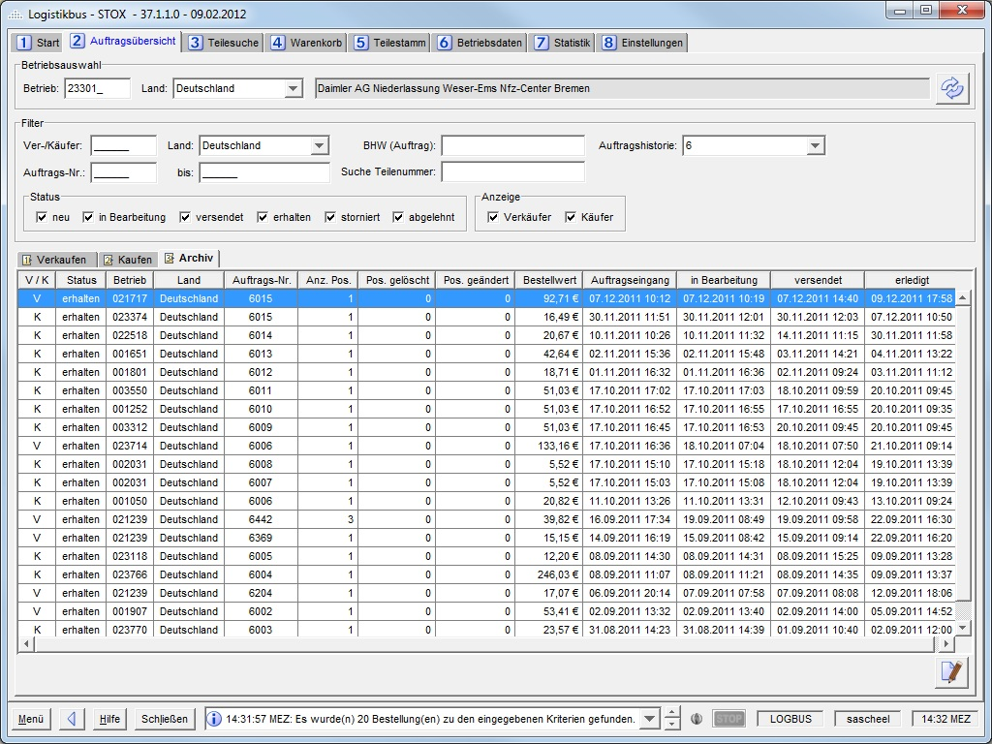

The system must allow the user to load and display orders - according to the filter criteria. This is done by clicking the *Load*button.

If the user confirms his entry in one of the following fields with the *Enter* key, the orders are loaded.

- Dealer number

- Order number from/to

- Seller/buyer

- Order reference

- Part number

| **Filter** | **Element** | **Format** | **Multiple** | **Other** | **Filtered field** |
| --- | --- | --- | --- | --- | --- |
| Country (dealer) | Combobox | Text | N |  | Own dealer number. |
| Dealer number | Text field | 6-digit, numeric | N |  | Own dealer number. |
| Country (seller/buyer) | Combobox | Text | N |  | Dealer number seller/buyer (of the business partner). |
| Seller/Buyer | Text field | 6-digit, numeric | N |  | Dealer number seller/buyer (of the business partner). |
| Order no. | Text field | 6 digits,  numeric | N | From - To | Order number. |
| Ordering information | Text field | max. 150 characters | N | Order note must contain the text. Case insensitive. | Special orderer's note to the order/order of the buyer. |
| Part number | Text field | max. 25 characters | N |  | Part number (input option in all part number formats, analog part search without wildcard) |
| Display depth | Combo box | Number | N | 6,12,18,24 (months) | Date of order receipt. |
| Status | Checkbox | - | J | new  in process  accepts  dispatches  get  canceled  rejected  expired (only visible in buyer's view) | Status of the order.  The status new corresponds in the D2D process to the two statuses "Created" and "Started" (D2DOrder/D2DRequest)  Visibility:  in process - only with DeadStock authorization  accepted, expired - only with D2D authorization |
| Purchase/Sale | Checkboxes |  | J | - | Type of order (dealer as buyer or seller). |
| Order process (DeadStock/D2D) | Checkboxes | - | J | One of the two checkboxes must always be selected | Order process DeadStock or D2D  If the user is only authorized for one of the two processes, this filter area will not be displayed |

The system issues an error message if the user enters a value that does not meet this criterion.

### Dealer data and user settings

In the *Dealer Data and User Settings* subpanel, the user can edit his addresses and contact information relevant for STOX and specify other dealer information relevant for STOX. In addition, the user can define his personal settings.

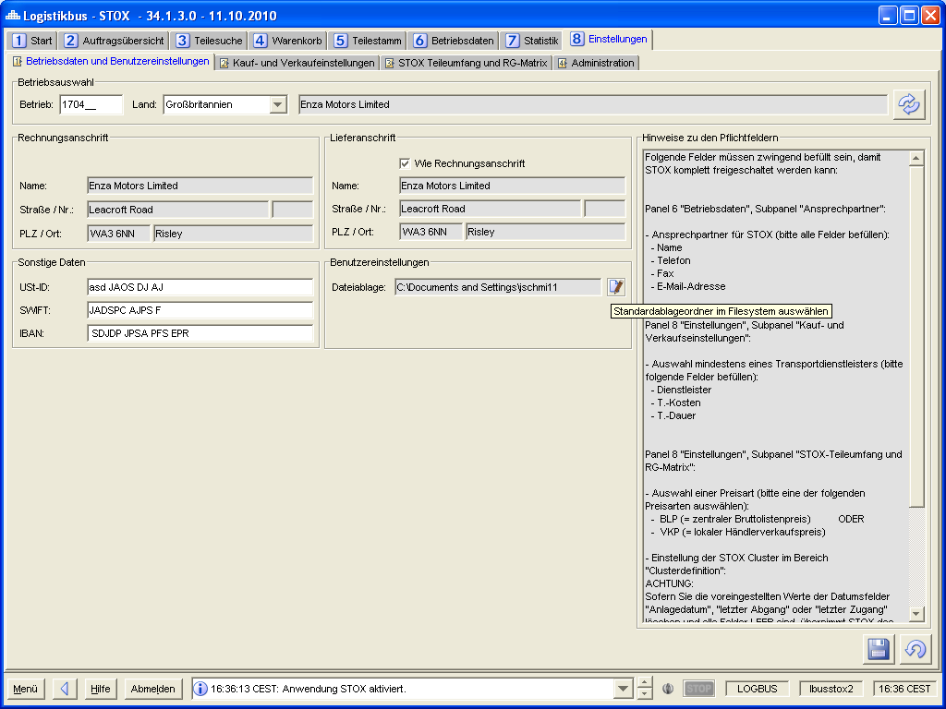

Dealer selection

Requirement: FKT-GUI-231

The system must provide the input fields Country (combo box) and dealer (text field, max. 6 digits, numeric).

Requirement: FKT-GUI-232

If the user confirms his entry in the dealer number field with the *Enter* key, the active dealer is set, and the settings are loaded.

Requirement: FKT-GUI-233

When you click the *Load* button, the system must set the active dealer. The requirements defined at 4.2.1 apply here.

Requirement: FKT-GUI-234

When clicking the *Load* button, the system must load the settings (STOX relevant dealer data for active dealer) after successfully setting the dealer.

Field description

Requirement: FKT-GUI-235

The system must provide and populate the following fields (if data is available). In the table, delivery address is abbreviated as LA and billing address as RA.

Requirement: FKT-GUI-237

If the user sets a checkmark in the *Different billing address* checkbox, the selection box of the dealer becomes active. In addition to the loaded dealer number (default), this also contains all Locations DS and Locations D2D incl. main and sub dealer of the currently active user (only complete dealer numbers without wildcards). Locations DS and Locations D2D that do not match the selected country in panel 8.1 are not displayed. If you select a different dealer number, its address will be used as the billing address. The values in the text fields cannot be changed manually. Initially the checkbox is disabled. This means that the billing address is the same as the address of the dealer in the dealer selection.

If the checkbox is deactivated again after an activation, the address of the dealer is automatically set again in the dealer selection and taken over as the billing address for this dealer the next time it is saved.

By default, the delivery address corresponds to the selected dealer number. However, this can be changed manually, i.e., the fields are editable (but there is no separate checkbox "Like billing address" or similar for this).

Requirement: FKT-GUI-418

If the checkbox for manually overwriting the delivery address is selected, the text fields of the delivery address become editable. Changes can be saved. There is then no synchronization of the GSSN data with the manual data of the delivery address. If the checkbox is deselected again, the delivery address again corresponds to the dealer data of the dealer.

Requirement: FKT-GUI-239

When you click the *Save* button, the system must save the changes made by the user to the database.

Requirement: FKT-GUI-240

When you click the *Discard Entries* button, the system must - after confirmation via a popup - discard the changes made by the user and set the previously loaded settings.

### Buy and sell settings

In the *Buy and Sell Settings* subpanel, the user can customize settings for buying and selling parts. This includes settings for the shipping methods offered as well as automatic order comments.

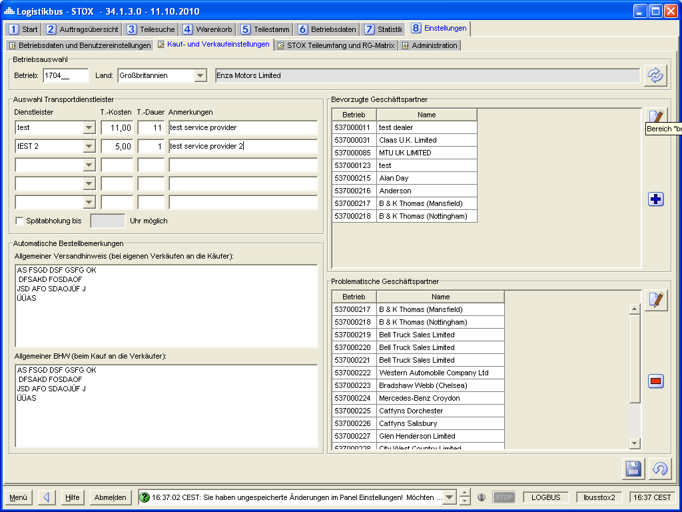 Dealer selection

Requirement: FKT-GUI-242

The system must provide the input fields Country (combo box) and dealer (text field, max. 6 digits, numeric).

Requirement: FKT-GUI-243

If the user confirms his entry in the dealer number field with the *Enter*key, the active dealer is set, and the settings are loaded.

Requirement: FKT-GUI-244

When you click the *Load* button, the system must set the active dealer. The requirements defined at 4.2.1 apply here.

Requirement: FKT-GUI-245

When you click on the *Load* button, the system must load the buy/sell settings and the dealer lists after the dealer has been successfully set.

Field description

Requirement: FKT-GUI-246

The system must provide and populate the following fields (if data is available). In the table, shipping type is abbreviated as VA. The defined shipping methods (transport service provider) apply to both processes (DeadStock and D2D).

| **Field** | **Element** | **Editable** | **Format** | **Content** |
| --- | --- | --- | --- | --- |
| 5x VA Name | Combobox | Y | - | Name of the postal service provider (the shipping method)  Selection from the 5 service providers of the market as well as input of a free text possible. |
| 5x VA costs | Text field | Y | Price format (currency identifier as tooltip) | Approximate cost of shipping (of a standard package). Mandatory field, if VA Name filled. |
| 5x VA expected duration | Text field | Y | Integer | Estimated time of shipment. Mandatory field, if VA Name filled. |
| 5x VA Notes | Text field | Y | Max. 100 characters | Comment on the shipping method. |
| VA late pickup possible | Checkbox | Y | - | Selected: Late pickup possible until xx o'clock. |
| VA Late collection until | Text field | Y | Max. 8 characters | Time until which collection is possible. Mandatory field if late pickup is selected. |
| Ordering information | Textarea | Y | Max. 2000 characters | Remark to be attached to outgoing orders (user as buyer). |
| Shipping note | Textarea | Y | Max. 1000 characters | Remark to be attached to incoming orders (user as seller). |
| Preferred suppliers | Table | N | Max. 200 dealers | List of preferred suppliers (dealer number and name). Editable via dealer list panel. Sorted in ascending order by dealer number. |
| Problematic suppliers | Table | N | Max. 200 dealers | List of problematic suppliers (dealer number and name). Editable via dealer list panel. Sorted in ascending order by dealer number. |

### Criteria: Part Scope and RG Matrix

In the *Part Scope and Discount Group Matrix* subpanel the user can make settings for the calculation of his DeadStock part scope as well as view the *discount* group matrix currently valid for STOX (DeadStock and D2D).

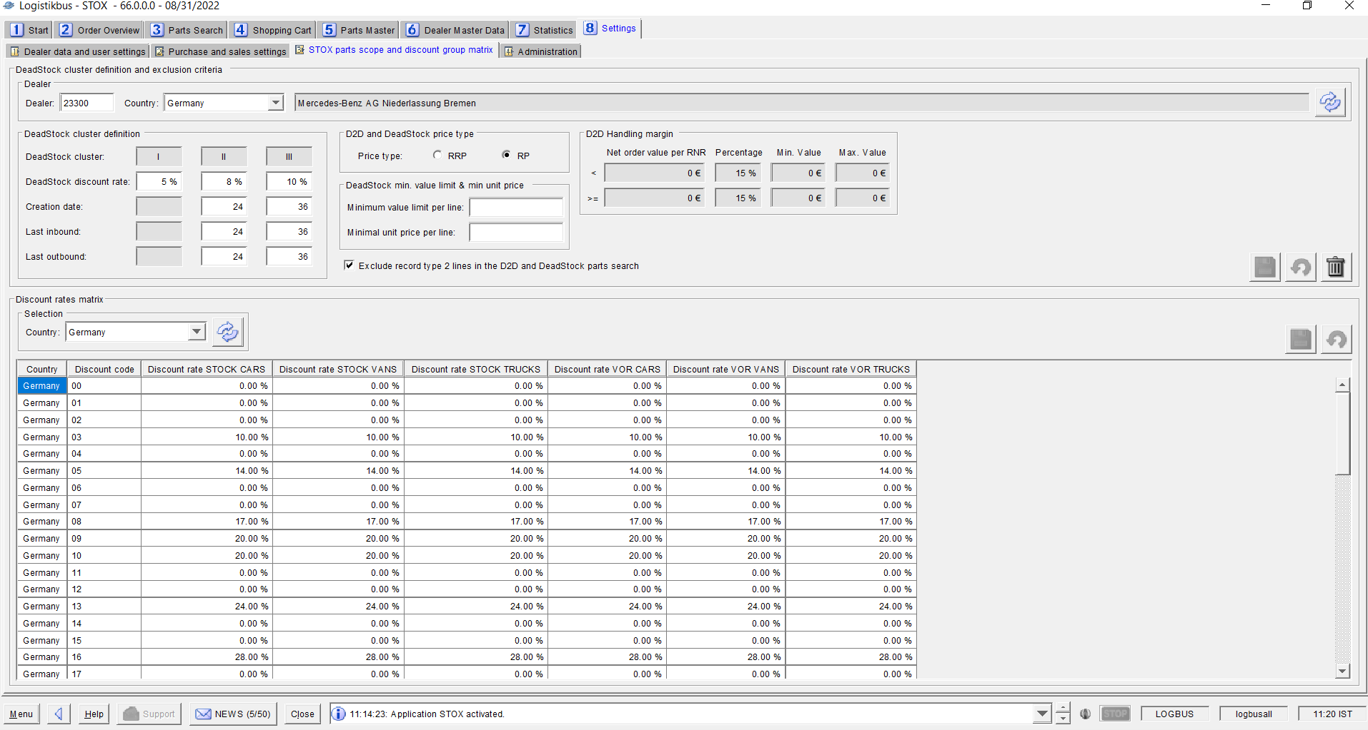

The "DeadStock Cluster Definition" area and the two fields "Minimum Value Limit per Item" or "Minimum Unit Price per Item" have no impact on the D2D process. If a user has no "DeadStock rights" (i.e., his *Locations DS* are empty), the fields are hidden.

#### Criteria part scope

Dealer selection

Requirement: FKT-GUI-254

The system must provide the input fields Country (combo box) and dealer (text field, max. 6 digits, numeric).

Requirement: FKT-GUI-255

If the user confirms his entry in the dealer number field with the *Enter*key, the active dealer is set, and the settings are loaded.

Requirement: FKT-GUI-256

When you click the *Load* button, the system must set the active dealer. The requirements defined at 4.2.1 apply here.

Requirement: FKT-GUI-257

When you click the *Load* button, the system must load the settings (for active dealer) after the dealer has been successfully set.

Field description

Requirement: FKT-GUI-258

The system must provide and populate the following fields (if data is available):

| **Field** | **Element** | **Editable** | **Format** | **Content** |
| --- | --- | --- | --- | --- |
| 3x DeadStock category | Text field |  | - | DeadStock categories I - III. |
| 3x DeadStock discount rate | Text field | Y | 2-digit integer between 0 and 99 | Discount rate in percent to DeadStock category. Default value of the market as tooltip. |
| 3x Investment date | Text field | Y | 2-digit integer | Definition of the maximum investment date (in months in the past). 2x editable (cluster II and III)  Default value of the market as tooltip. |
| 3x last access | Text field | Y | 2-digit integer | Definition of the maximum date of the last receipt (in months in the past). 2x editable (cluster II and III)  Default value of the market as tooltip. |
| 3x last exit | Text field | Y | 2-digit integer | Definition of the maximum date of the last departure (in months in the past). 2x editable (cluster II and III)  Default value of the market as tooltip. |
| Price type BLP | Radio button | Y | - | Radiobuttongroup Price type: Selection BLP. |
| Price type VKP | Radio button | Y | - | Radiobuttongroup Price type: Selection VKP. |
| Min. value limit per pos. | Text field | Y | Price format without currency identifier | Minimum value limit per position (lower limit). |
| Min. unit price per pos. | Text field | Y | Price format without currency identifier | Minimum unit price per position (lower limit). |
| Exclude SA2 | Checkbox | Y | - | Exclude record type 2 from STOX part scope. |

Table 4‑50 - Panel settings: Fields Overview Subpanel Part Scope

Requirement: FKT-GUI-259

The system must disable the BLP price type when the user selects the VKP price type.

The system must disable the VKP price type when the user selects the BLP price type.

The selected price type applies to both the D2D and DeadStock processes.

Requirement: FKT-GUI-260

The monthly values *(investment date, last retirement* and *last acquisition*) may only be editable for DeadStock Clusters II and III.

Requirement: FKT-GUI-310

When filling the input fields of the monthly values, the system must check whether the values in cluster III are larger than those in cluster II. If not, an error message will be displayed.

Requirement: FKT-GUI-261

The system must check the entered monthly values *(creation date, last retirement* and *last acquisition*) for the associated bandwidths[1] before saving. If a monthly value exceeds or falls below the associated bandwidth, an error message is displayed to the user with the associated field and the lower and upper limit values. Saving is canceled.

Requirement: FKT-GUI-262

Before saving, the system must check that the user enters either none or both monthly values of a criterion *(creation date, last retirement* and *last acquisition*). If the user has filled in only one monthly value for a criterion, a meaningful error message is displayed to the user. Saving is canceled.

Examples:

The user enters for the criterion

- *last exit for* both cluster II and cluster III no value🡪 OK

- *Creation date* enter a value for cluster III and leave cluster II empty 🡪 Not OK

Requirement: FKT-GUI-263

The system must check the entered minimum values *(min. value limit* and *min. price per position*) for the market-specific maximum value[2] before saving. If a minimum value exceeds the associated maximum value, an error message is displayed to the user with the associated field as well as the maximum possible input value. Saving is canceled.

Requirement: FKT-GUI-264

The system must check if a price type is selected before saving. If no price type is selected, an error message is displayed to the user and saving is aborted.

Requirement: FKT-GUI-265

When the user clicks on the *Discard entries* button, the system must - after confirmation via a popup - discard the user's entries and set the previously loaded settings.

Requirement: FKT-GUI-266

When you click the *Save* button, the system must perform the checks described above and, if successful, save the user input to the database.

Changes to the price type take effect live in STOX (for new part searches) after successful save.

When the settings are saved for the first time (if not changed), the default values for DeadStock discount rate, Investment date, Date l. Addition and Date l. Retirement are saved. If the default values change after saving, they are not automatically applied[3].

When the settings are successfully saved, the system checks whether any of the following parameters have changed (i.e., the value has been changed or deleted):

* Number of months for date of installation, last retirement or last acquisition
* Minimum value limit or unit price per item
* Price type (only if a minimum value limit or unit price per position is set)
* Exclusion record type 2 positions

If one of these parameters is changed, an identifier is set to perform a deletion of the existing assortment beforehand during the next assortment calculation (see section 1.1.2).

#### Discount group matrix

Requirement: FKT-GUI-268

The user must be able to select a country in a combo box *(RG country*).

Requirement: FKT-GUI-269

When you click the *Load discount groups* button, the system should load the discount group matrix for the selected country.

Requirement: FKT-GUI-270

The system must display one discount group per row in the *RG Matrix* table with the following columns (depending on whether the "FUTURE active as of" date from the country-specific parameters for the country has already been reached, different columns are displayed for maintaining the discount rate.

| **Column** | **Format** | **Display** |
| --- | --- | --- |
| Country | Text | Country in which the discount group is valid (Corresponds to the country from the combo box *RG country*). |
| Discount group | 5 digits | Discount Group Number. |
|  |  |  |
| Only for NON-FUTURE markets (countries) | | |
| Discount rate (LAG) | Percentage. 2 digits with decimal places | Discount rate of the associated discount group (editable for admin). |
| Discount rate (VOR) |
|  |  |  |
| Only for FUTURE markets (countries) | | |
| Discount rate CARS (LAG) | Percentage. 2 digits with decimal places | Discount rate of the associated discount group (editable for admin). |
| Discount rate VANS (LAG) |
| Discount rate TRUCKS (LAG) |
| Discount rate CARS (VOR) |
| Discount rate VANS (VOR) |
| Discount rate TRUCKS (VOR) |

Table 4‑53 - Panel settings: Columns of the RG matrix table

Requirement: FKT-GUI-271

The Discount Rate column must be editable for users in the *Admin Controller* role. Numerical values between 0.00 and 99.99 can be entered.

Requirement: FKT-GUI-272

When you click the *Save* button, the system should save the changes to the discount group matrix in the database. The change of the discount group will only affect future part searches or orders!

Requirement: FKT-GUI-273

The *Save* and *Discard* buttons may only be visible to the Admin Controller role.

Requirement: FKT-GUI-274

When you click the *Discard entries* button, the system must discard the user's entries - after confirming them via a popup - and set the previously loaded settings.

Requirement: FKT-GUI-275

For the *Retailer*, *Retaileradmin* and *Market Controller* roles, the combo box is restricted to the countries for which the user is authorized via the *Locations DS* and *Locations D2D* parameters.

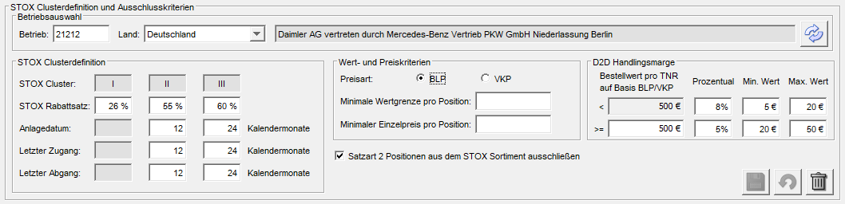

### Administration

The *Administration* subpanel is designed for admin control. These can change general parameters here and define bandwidths for dealer settings. All settings are market specific. This means that the user must first select a market (country) and can then adjust its settings.

Requirement: FKT-GUI-276

The *Administration* tab is displayed only for users in the *admin* role.

Requirement: FKT-GUI-277

The system must provide the user with a possibility to select the market and load the settings for this market (Market combo box and *Load*button).

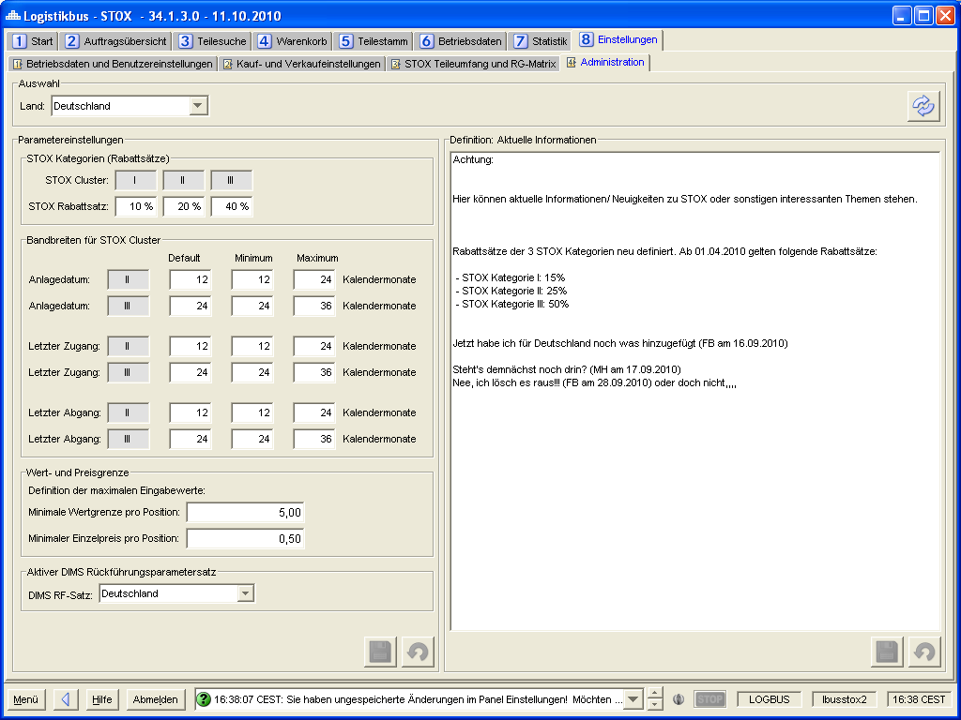

Figure 4‑24 - Panel settings: Administration

Field description

Requirement: FKT-GUI-278

The system must provide and populate the following fields:

| **Field** | **Element** | **Editable** | **Format** | **Content** |
| --- | --- | --- | --- | --- |
| Market | Combobox | Y | Country as text | Selection of the market for which the parameters will be loaded. |
| 3x DeadStock category | Text field |  | - | DeadStock categories I - III. |
| 3x DeadStock discount rate | Text field | Y | 2-digit number between 0 and 99 | Default value for the DeadStock discount rate to the DeadStock category in percent. |
| 2x Creation date Default value | Text field | Y | 2-digit number between 0 and 99 | Default value for the *investment date* criterion (in months). |
| 2x investment date  Minimum | Text field | Y | 2-digit number between 0 and 99 | Minimum value (lower limit) for the criterion *investment date* (in months). |
| 2x investment date  Maximum | Text field | Y | 2-digit number between 0 and 99 | Maximum value (upper limit) for the criterion *investment date* (in months). |
| 2x last access Default value | Text field | Y | 2-digit number between 0 and 99 | Default value for the criterion *last receipt* (in months). |
| 2x last access  Minimum | Text field | Y | 2-digit number between 0 and 99 | Minimum value (lower limit) for the criterion *last receipt* (in months). |
| 2x last access  Maximum | Text field | Y | 2-digit number between 0 and 99 | Maximum value (upper limit) for the criterion *last receipt* (in months). |
| 2x last outgoing Default value | Text field | Y | 2-digit number between 0 and 99 | Default value for the criterion *last departure* (in months). |
| 2x last exit  Minimum | Text field | Y | 2-digit number between 0 and 99 | Minimum value (lower limit) for the criterion *last departure* (in months). |
| 2x last exit  Maximum | Text field | Y | 2-digit number between 0 and 99 | Maximum value (upper limit) for the criterion *last departure* (in months). |
| Min. value limit per pos. | Text field | Y | Price format without currency identifier | Maximum input value by traders for the criterion *Min. value limit per position*. |
| Min. price per pos. | Text field | Y | Price format without currency identifier | Maximum input value by traders for the criterion *Min. unit price per item*. |
| RF parameter set | Multi-Select combo box | Y | - | Traceability record or records of the selected country to be used for the exclusion of traceable parts when determining the DeadStock assortment (RF type DIMS only).  If at least one feedback record is true, the part is excluded from the DeadStock range. |
| Latest STOX information | Textarea | Y | - | Current STOX information displayed on the home page. |

Table 4‑55 - Panel settings: Field overview Subpanel Administration

Requirement: FKT-GUI-279

When you click the *Load* button, the system should load the parameters and the info text for the selected store.

Requirement: FKT-GUI-311

The entered default value must be between the minimum and maximum value. In case of incorrect entry, an error message is displayed when leaving the input field.

Requirement: FKT-GUI-312

The entered minimum value must be smaller than the default value and the maximum value. In case of incorrect entry, an error message is displayed when leaving the input field.

Requirement: FKT-GUI-313

The entered maximum value must be greater than the default value and the minimum value. In case of incorrect entry, an error message is displayed when leaving the input field.

Requirement: FKT-GUI-280

When you click the *Discard Entries* button, the system must - after confirming via a popup - discard the user entries and set the previously loaded settings.

Range *parameters*: Discards the changes made to the parameters.

Area *current STOX information*: Discards the changes to the info text.

Requirement: FKT-GUI-281

When you click the *Save* button, the system must save the parameters or the info text to the database

1. Defined per store in the settings - Administration panel
2. Defined per store in the settings - Administration panel
3. Decided on meeting 12.04.2010 in Karlsruhe